**NUMPY ARITHMETIC OPERATIONS**

**import numpy as np**

**a=np.array(9)**

**print("Print A= ",a)**

**b=np.array([10,20,30])**

**print("Print B= ", b)**

**addition= np.add(a,b)**

**print("After Addition =", addition)**

**subtraction=np.subtract(b,a)**

**print("After Subtraction =",subtraction)**

**mul=np.multiply (a,b)**

**print("After Multiplcation =",mul)**

**div=np.divide (b,a)**

**print("After Division =",div)**

**div1=np.divide (b,5)**

**print("After Division =",div1)**

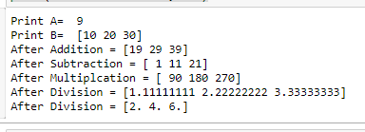

**#reciprocal**

**a= np.array([0.25,1.33,1,111])**

**print(a)**

**rec=np.reciprocal(a)**

**print(rec)**

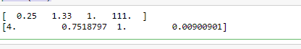

**a=np.array([10,100,1000])**

**print(a)**

**pow=np.power(a,2)**

**print("after ^2 = ", pow)**

**b=np.array([2,3,1])**

**pow1=np.power(a,b)**

**print("after b array elements as ^ = ", pow1)**

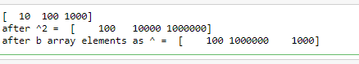

**a= np.array ([10,20,30])**

**b= np.array ([3,5,7])**

**print("values of A=", a)**

**print("values of B=", b)**

**mm=np.mod(a,b)**

**rm=np.remainder(a,b)**

**print("values of MOD=", mm)**

**print("values of REMAINDER=", rm)**

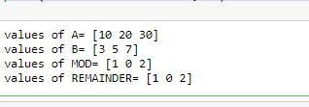

**a=np.array([-5.6j, 0.2j,11, 1+1j])**

**print(a)**

**print("real=",np.real(a))**

**print("imaginary=",np.imag(a))**

**print("Conjugate=", np.conj(a))**

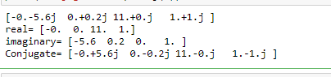

**a=np.array ([1.0,5.3,123,0.56,25.5,32])**

**print(a)**

**print("after rounding up=", np.around(a))**

**print("after rounding up to 1st decimal value =", np.around(a,decimals=1))**

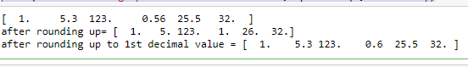

**a=np.array ([1.0,-5.3,123,-0.56,25.5,32])**

**print(a)**

**print('\n')**

**print(np.floor(a))**

**print(np.ceil(a))**

